App

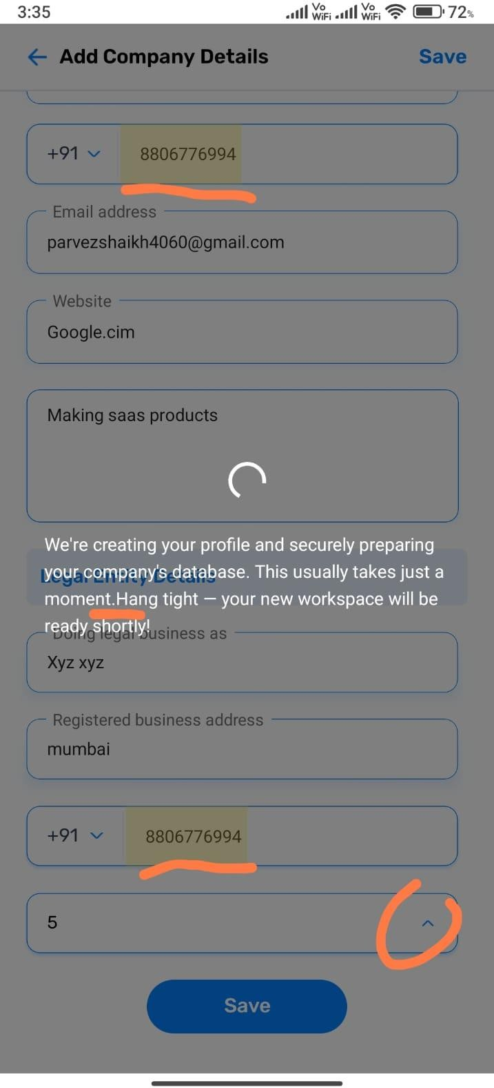
The text that appears after saving is missing a space after the full stop.

Figma App
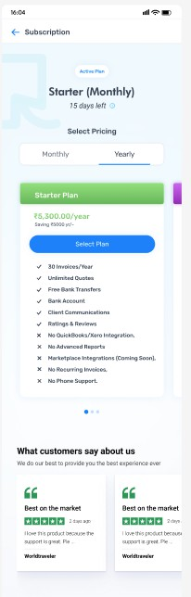
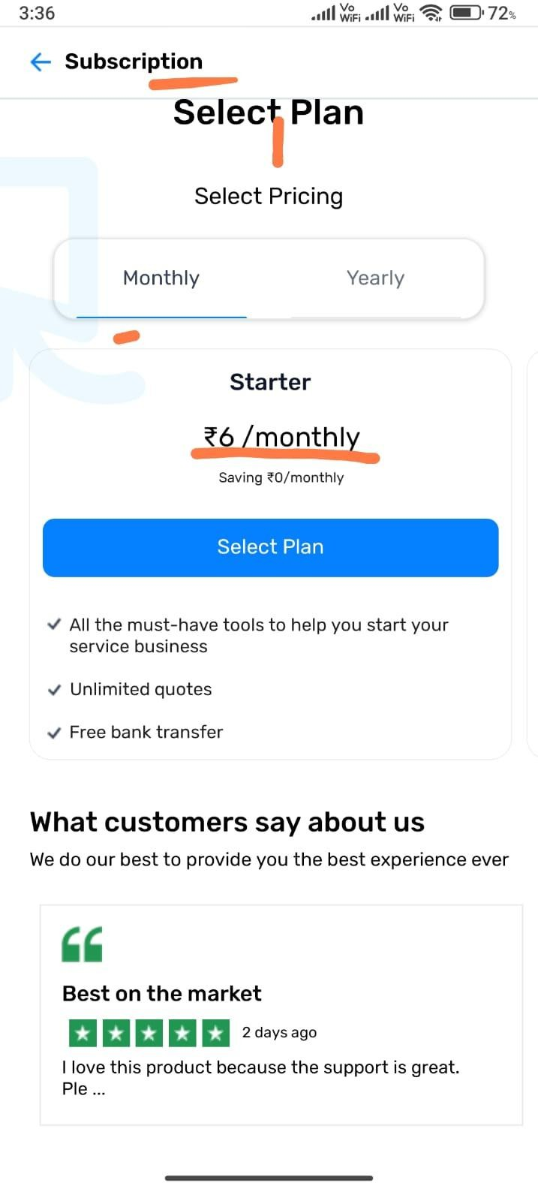

In this section, there is too much space below the 'Select Plan' button. Also, the text and design don't match well. The 'What Customers Say' card sizes are also inconsistent.

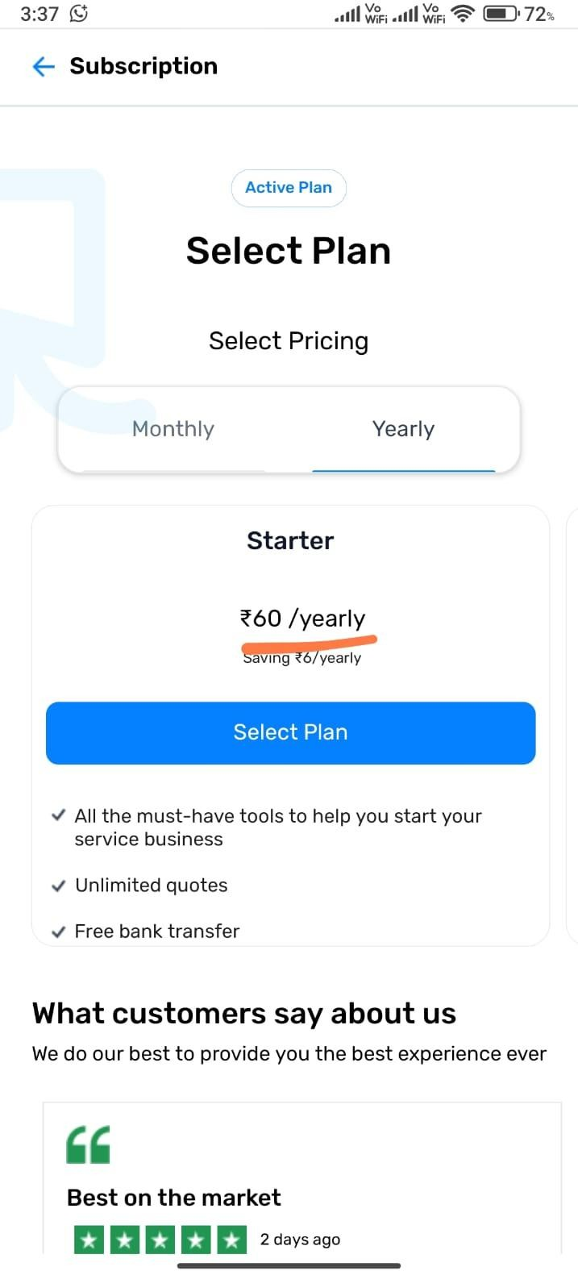

App
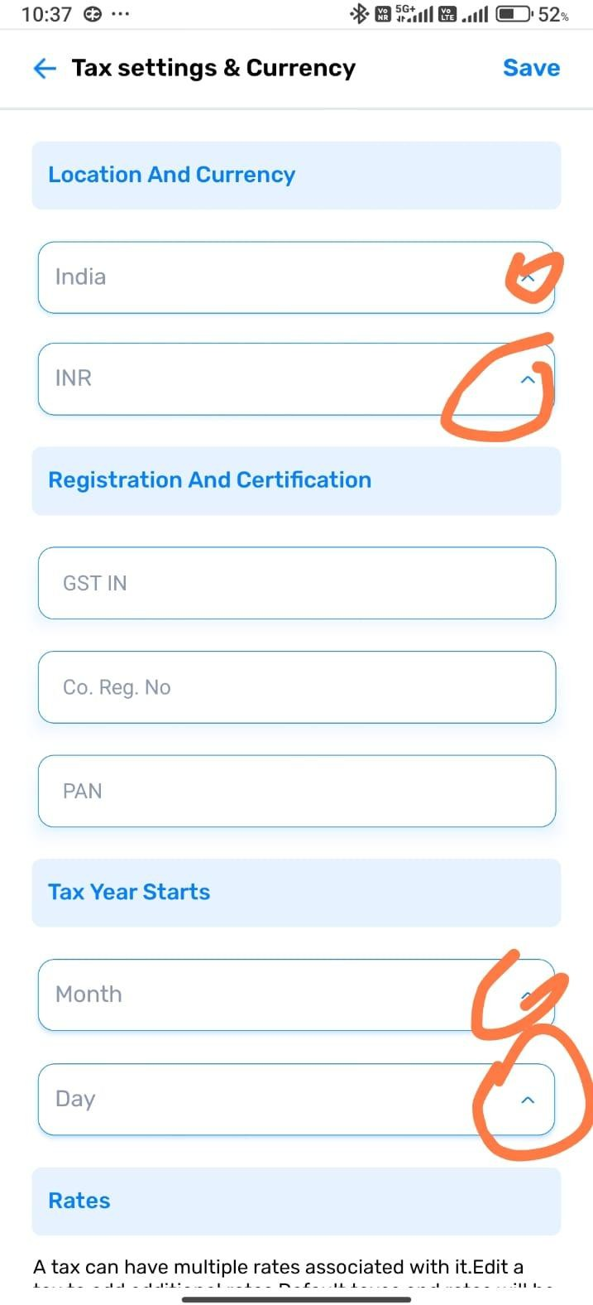

In this section, the dropdown is already open by default

App
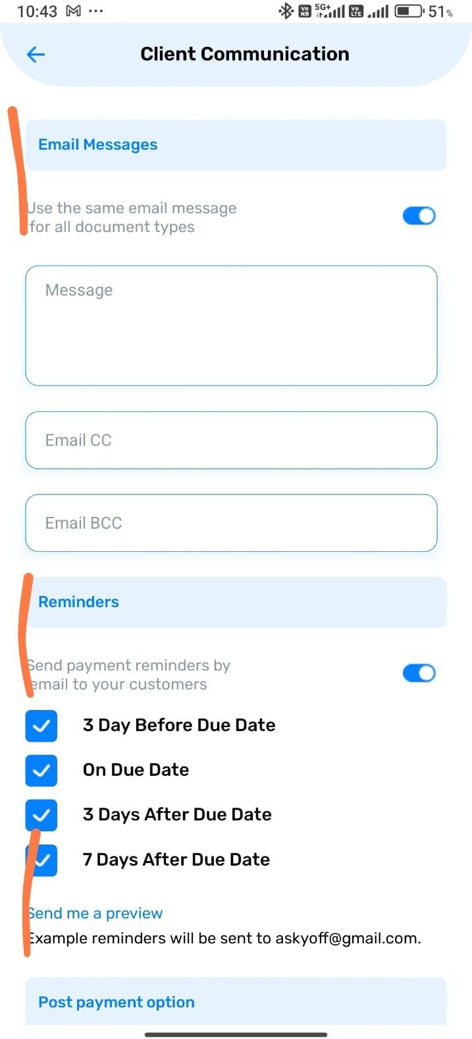
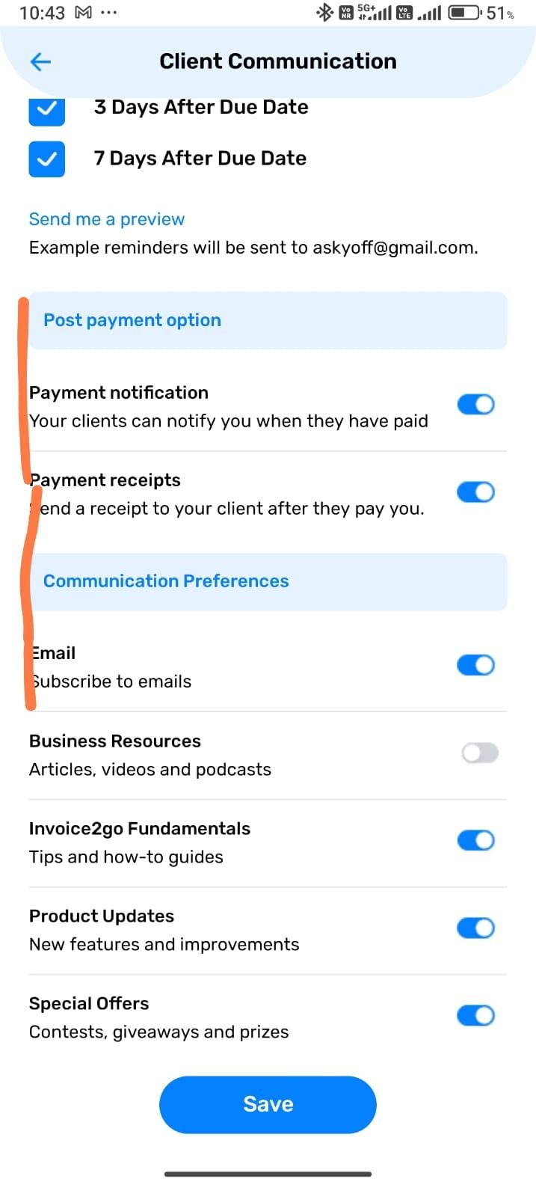
In Client Communication, the text is not properly aligned

App
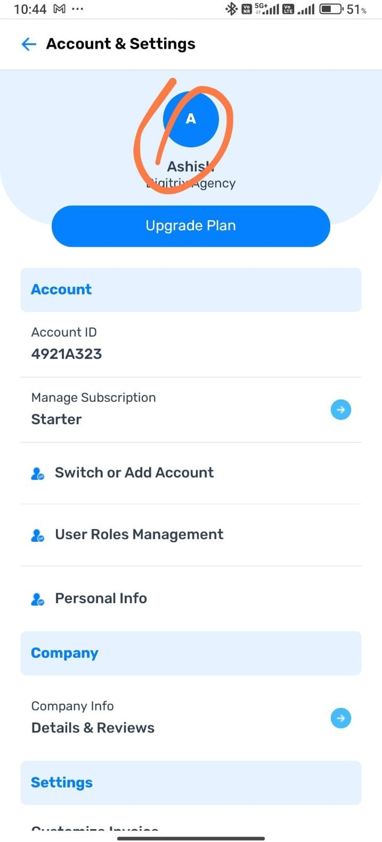

There is no profile edit option in Account Settings. If someone wants to make changes to their profile, there’s no way to do it

App
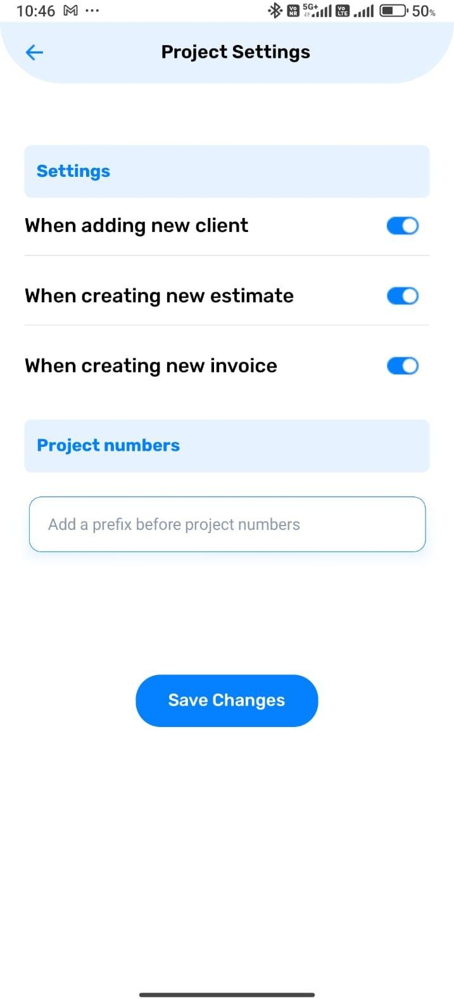
Text size and alignment are not proper

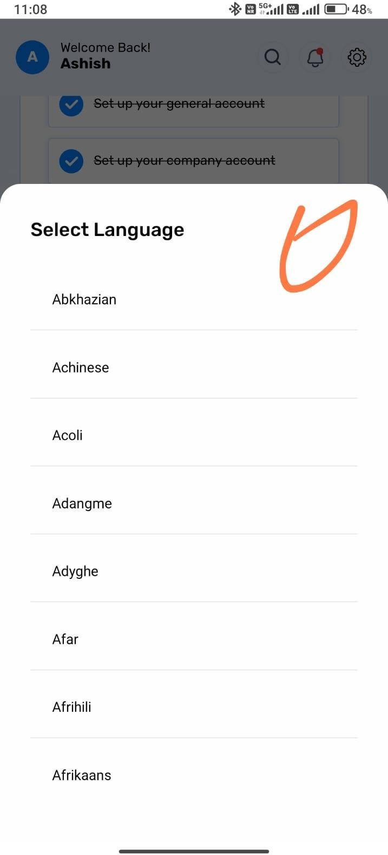

I think the language selector should have a search option and an alphabetical (A to Z) filter.

App
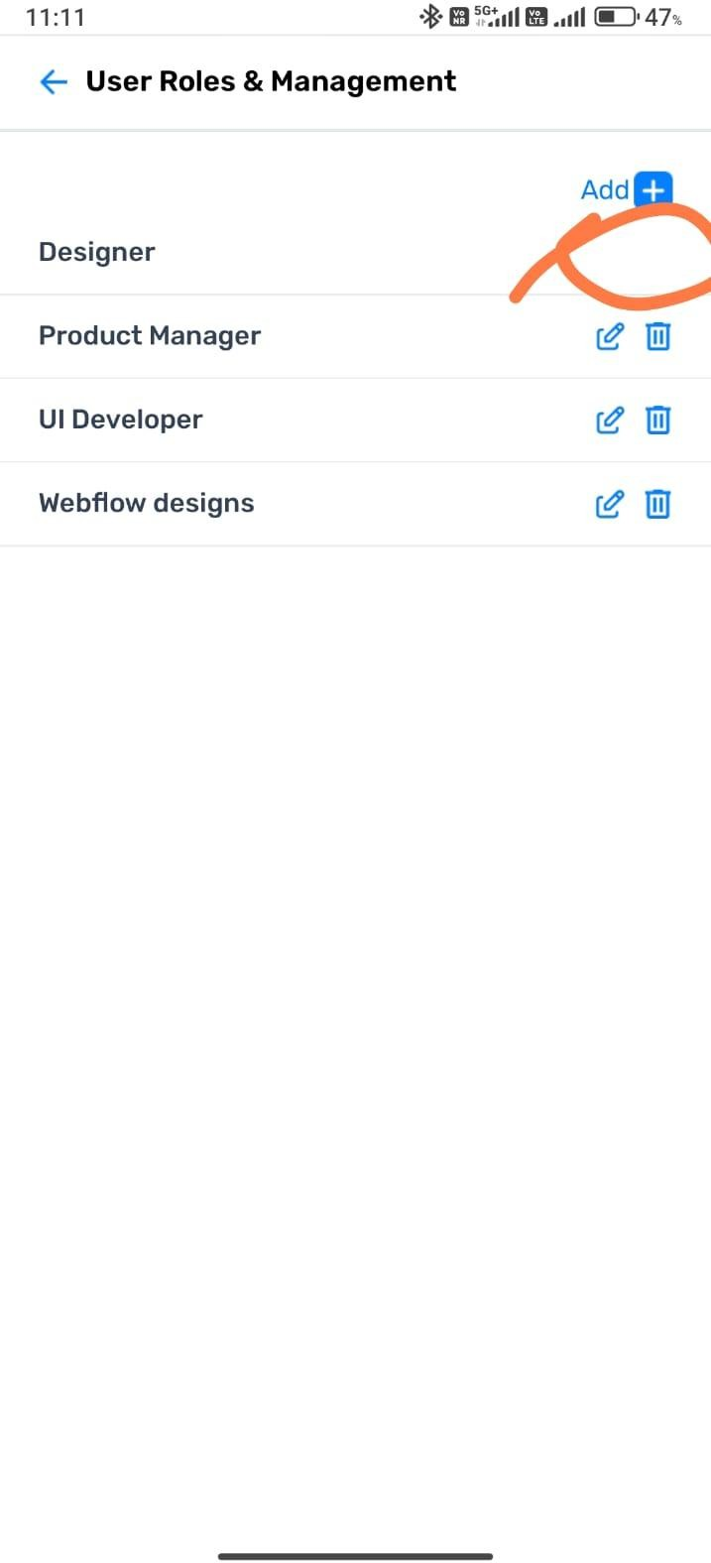
In User Roles, after selecting a user, the edit and delete options are not showing for the first one. Also, in Switch Account, it doesn’t show whether the access is full or limited. There should also be an option to manage access from there.

=====================================================================

Figma App
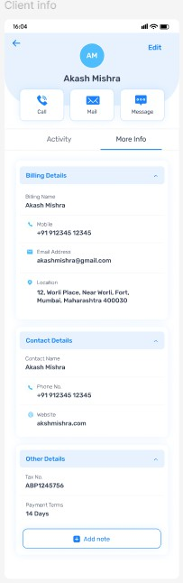
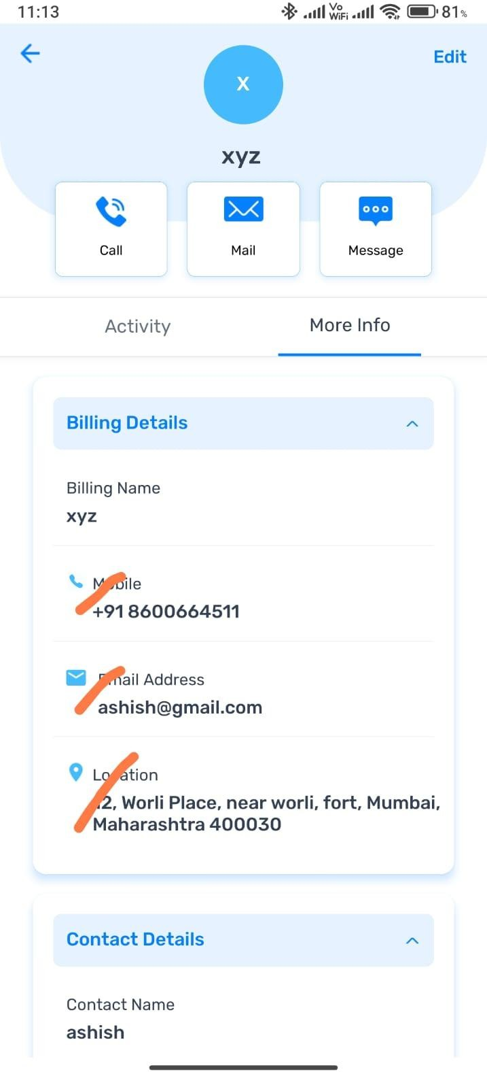

The icon placement in the Client Info section is not correct.

Figma App
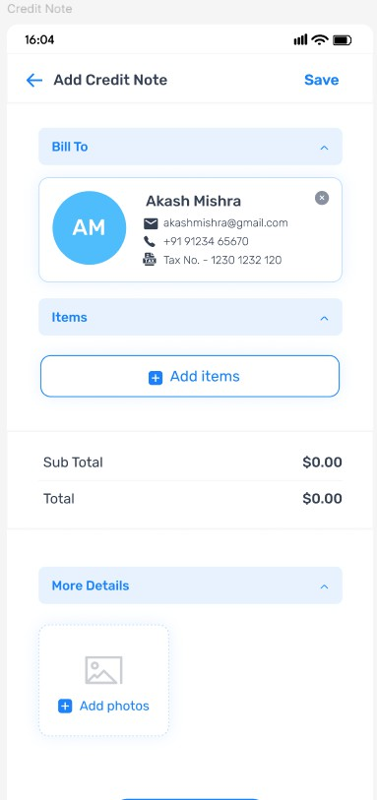
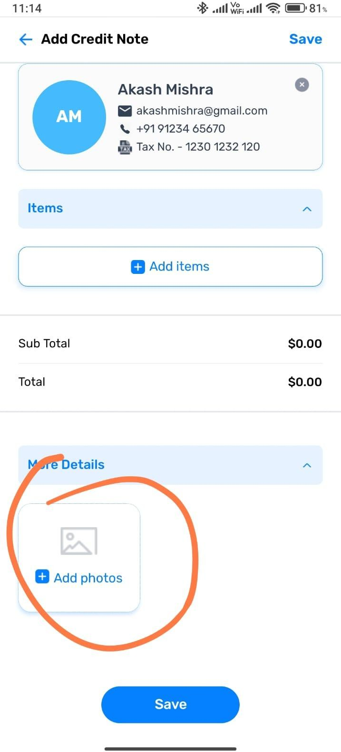

In the 'Add Client Note' section, a dashed border is used around the image, but in the app, it's a solid line

Figma App
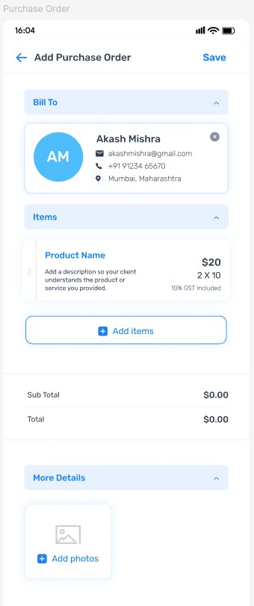
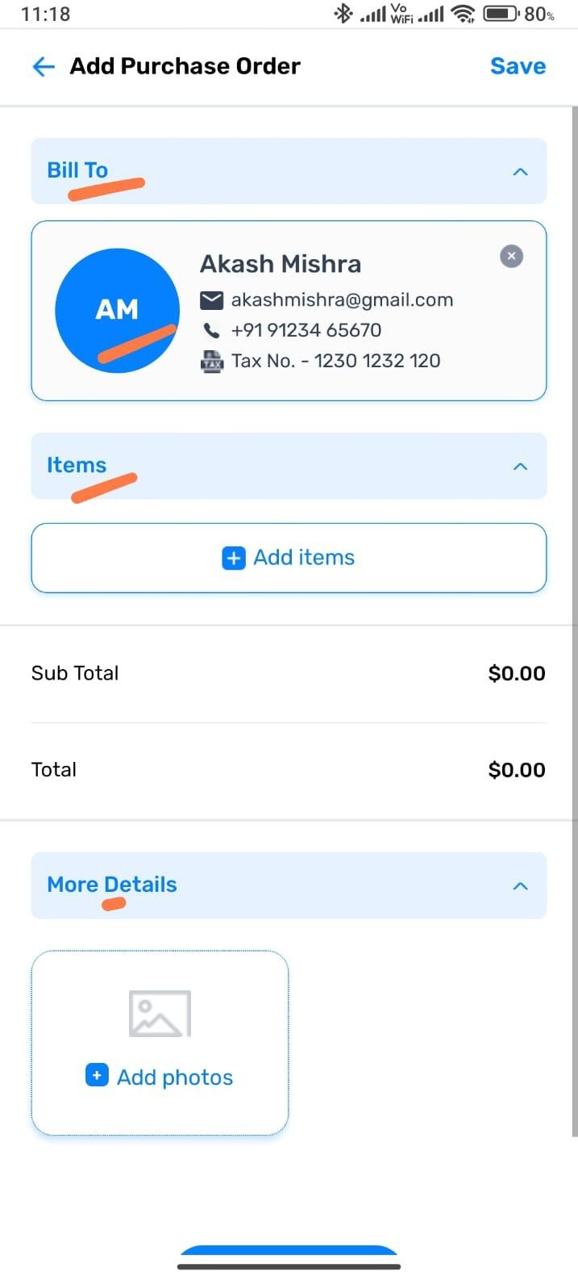
In the 'Add Purchase Order for Me' section, the profile icon color is different from the rest of the app.

Figma App
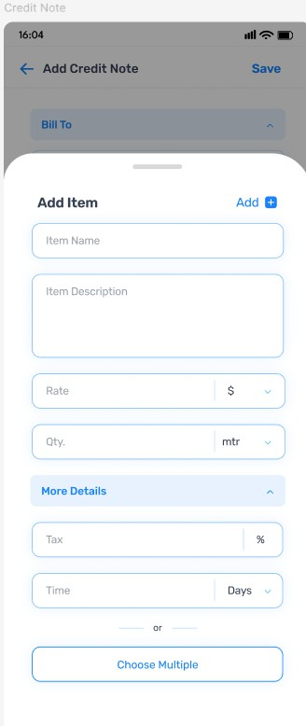
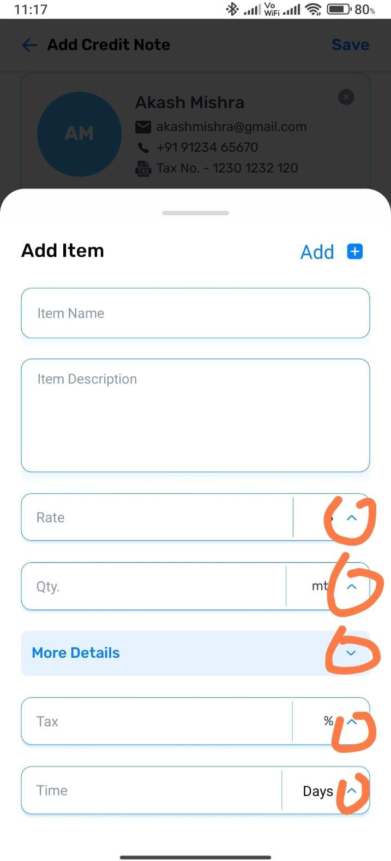

In the 'Add Item' section, all the dropdown icons are facing the wrong direction.

Figma App
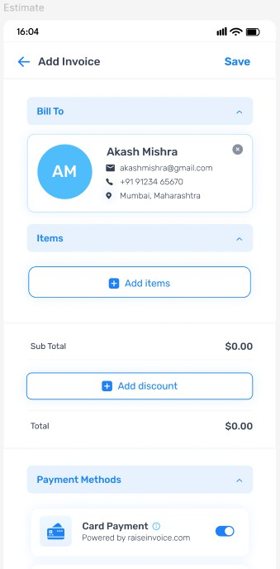
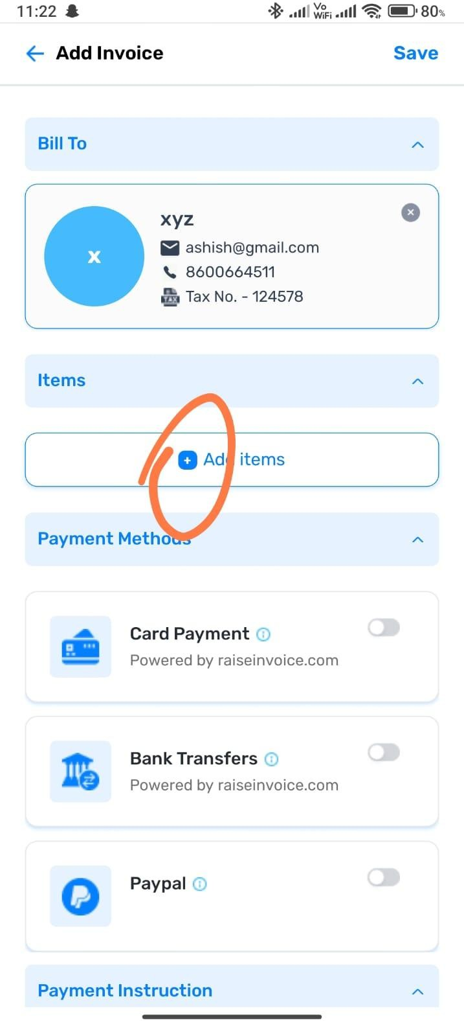

In the 'Add Invoice' section, the plus icon for adding an item is different

Figma App
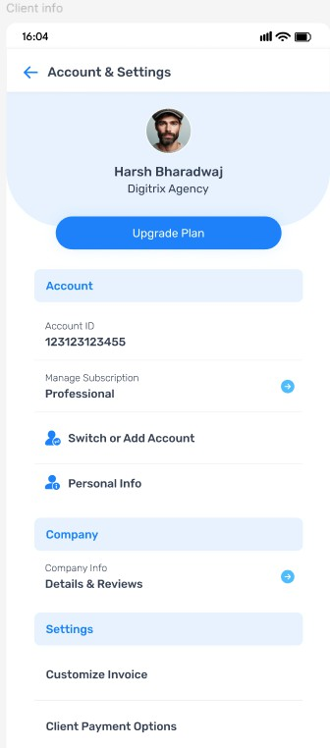
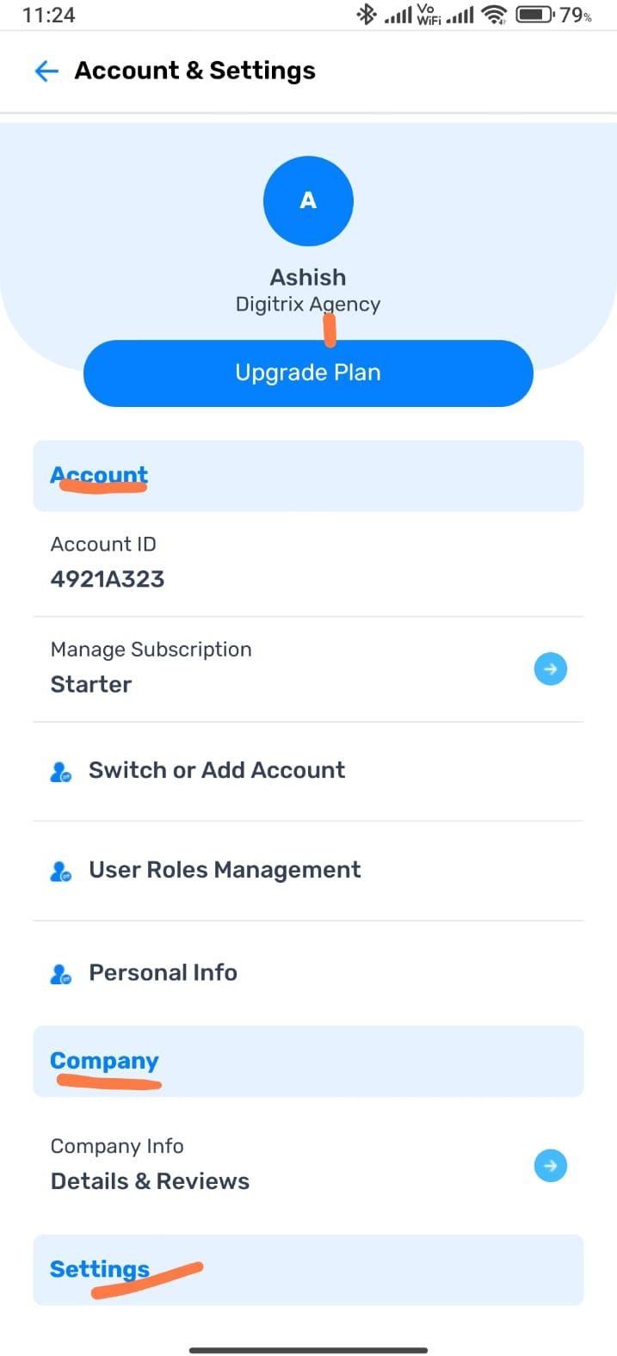

In Account Settings, there is too little space below 'Digitrix,' and the text color doesn’t match the rest

Figma App
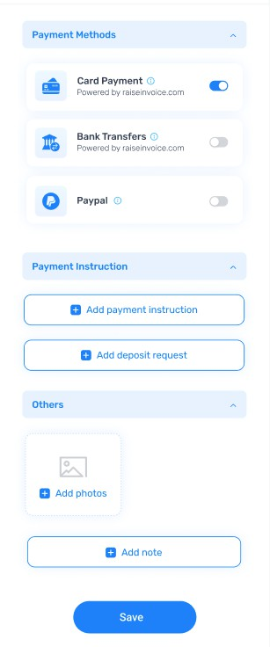
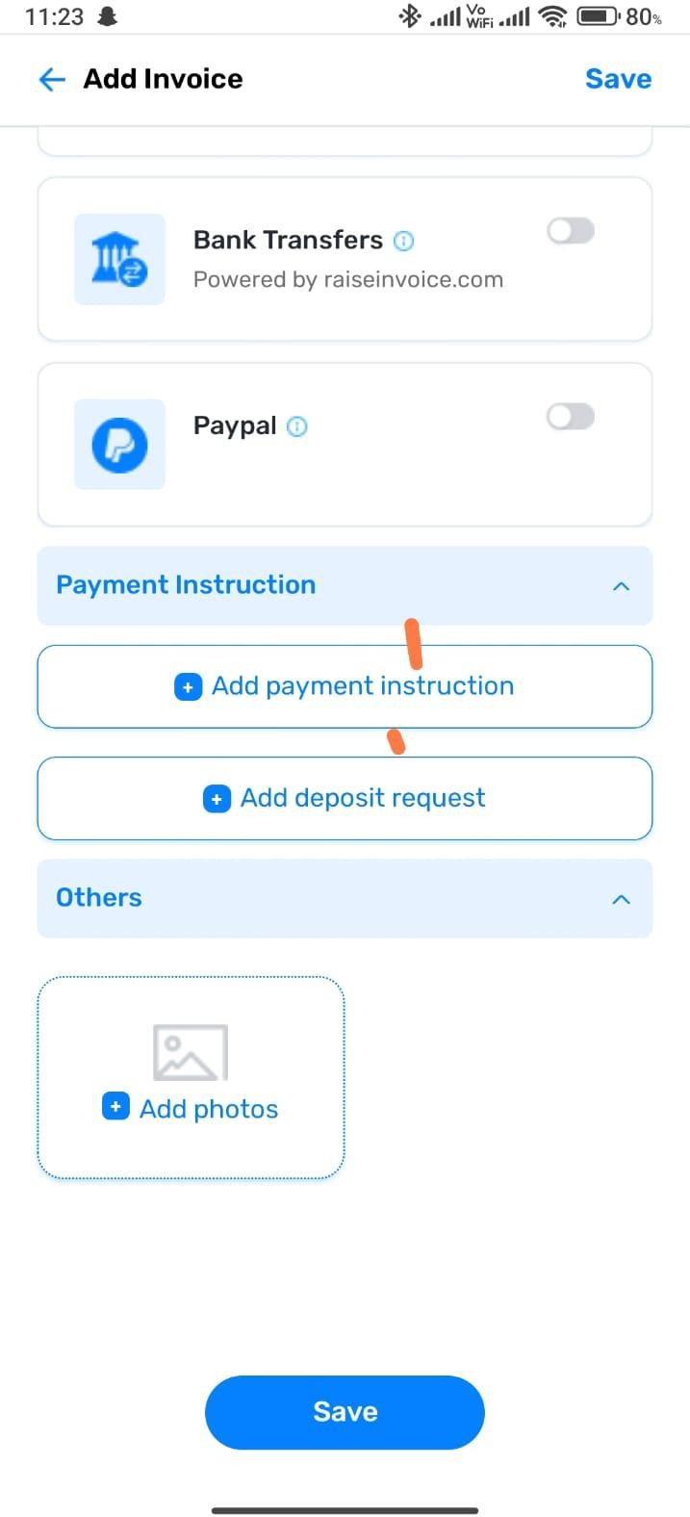

There is a spacing issue in this section, and the 'Add Note' option is missing after 'Add Photo

======================================================
======================================================

TAB View

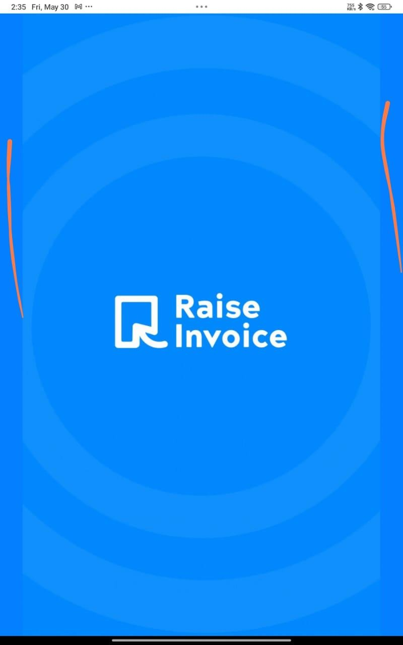
The loading indicator is not displaying properly — it looks cropped or cut off.

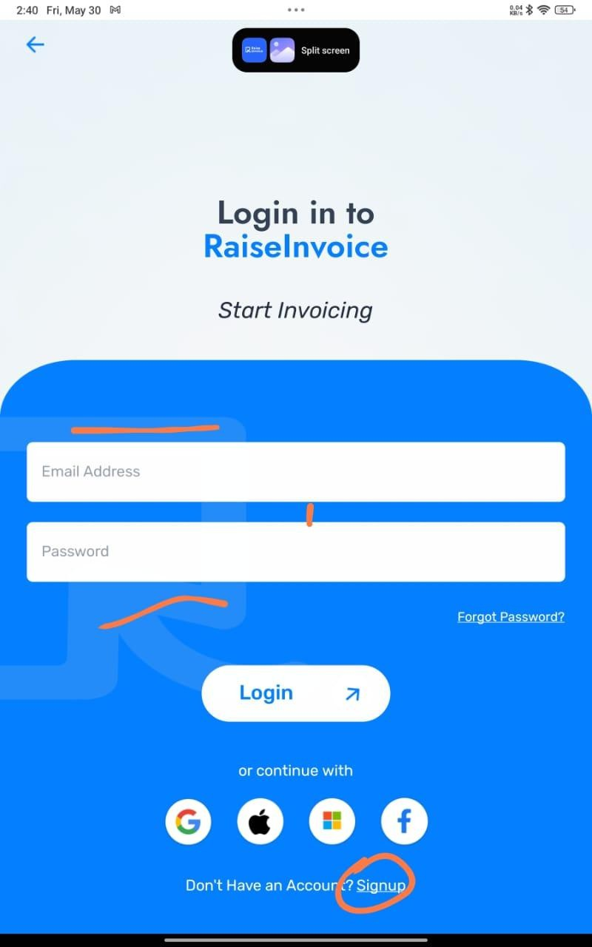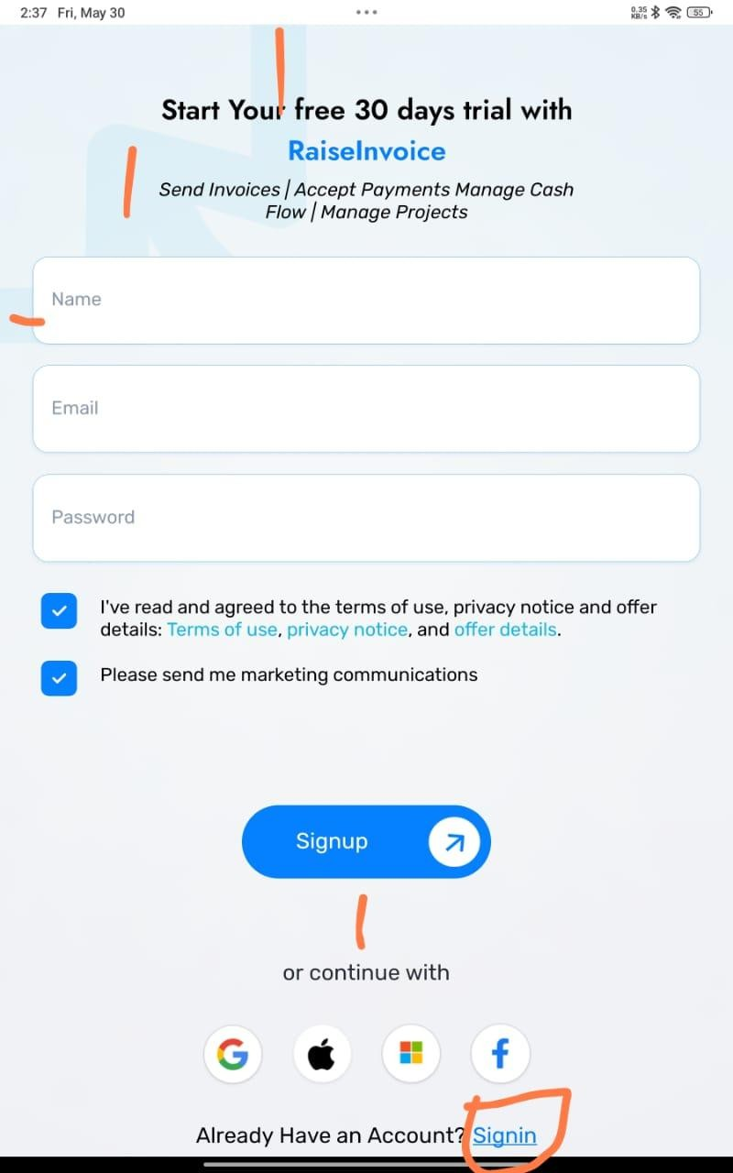

There is an issue with the buttons on the Login and Signup pages, and the text has too much gap (spacing).

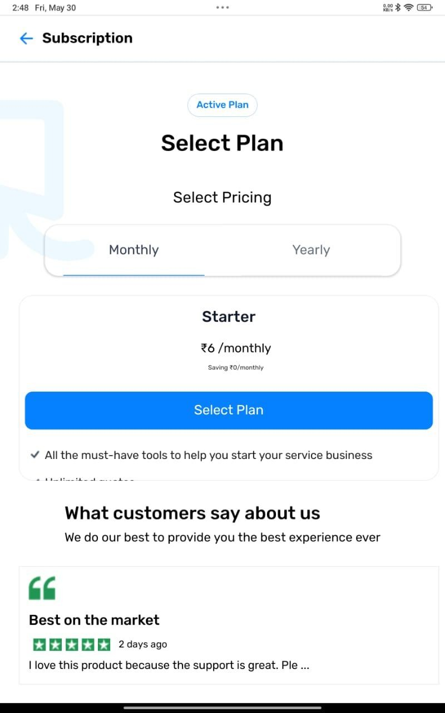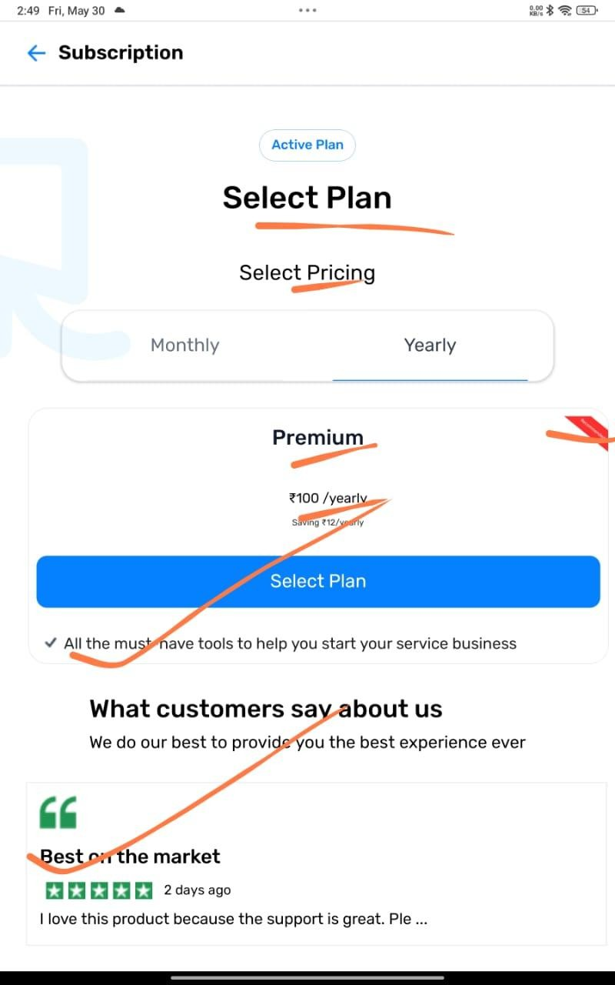

In the Subscription section, there is a problem with the font and text size. The card design is also not proper, and the Testimonials section doesn't look right either

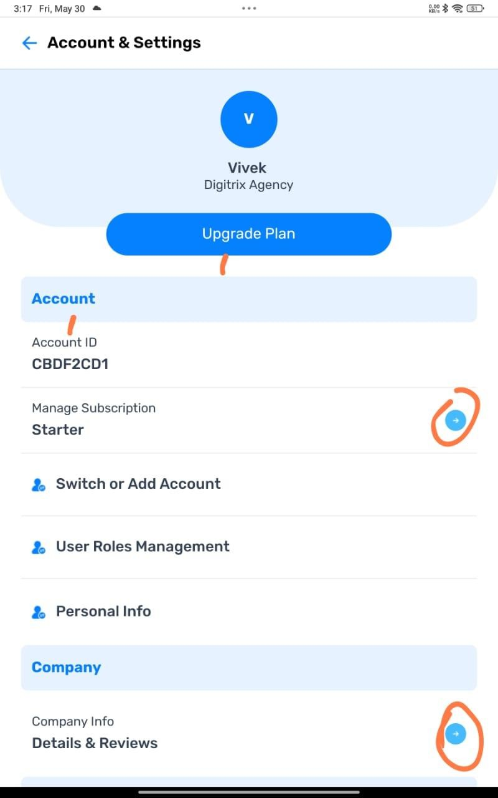

There is a spacing issue in this section, and the total values are not matching correctly when viewed on a phone.

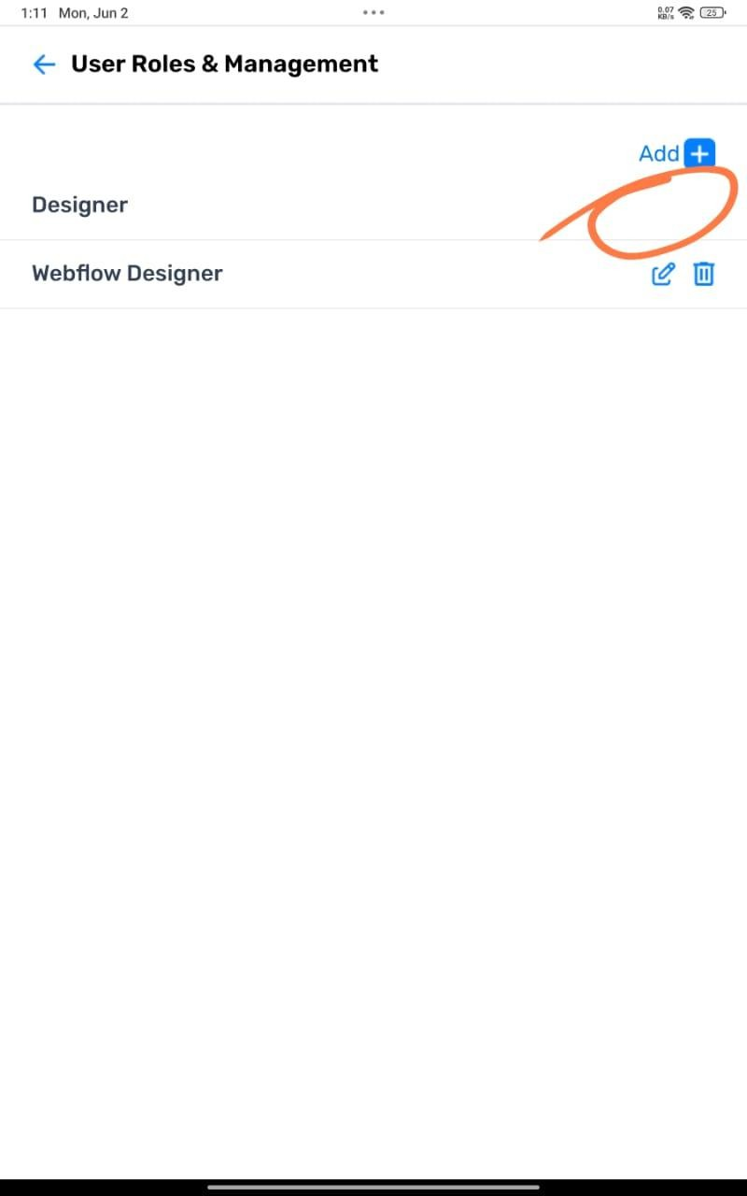

In this section, after selecting roles, the edit and delete options are not showing for the first selected role.

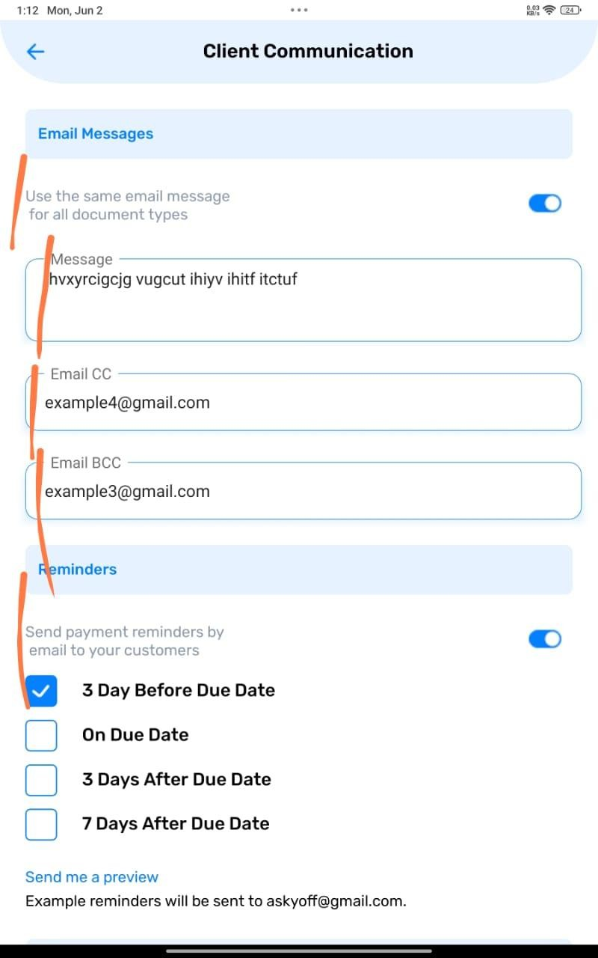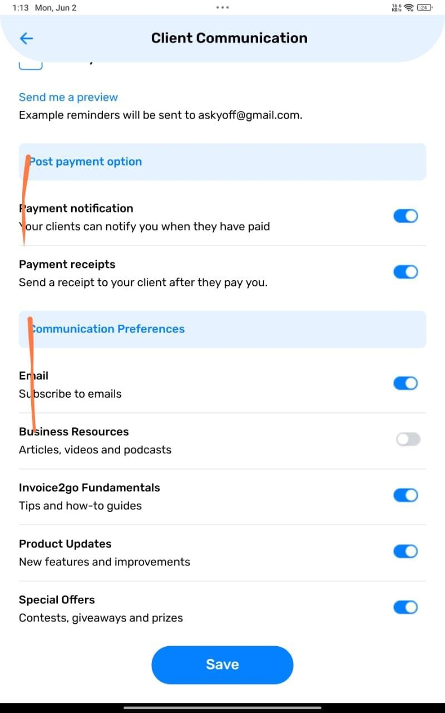

In this section, the font size and alignment are not proper

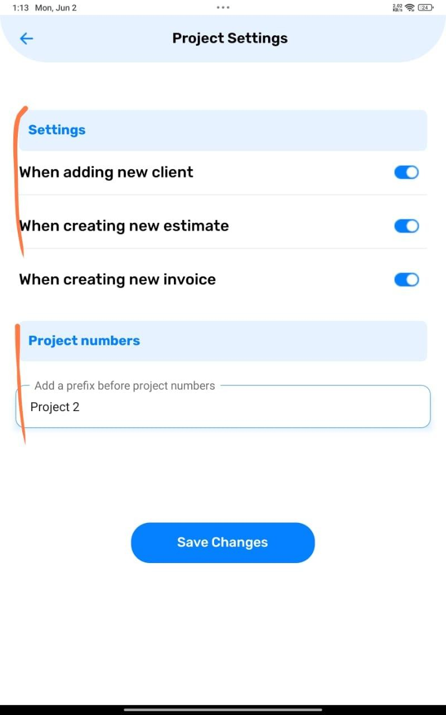

In this section, the subheading is larger than the main heading, which creates a visual hierarchy issue

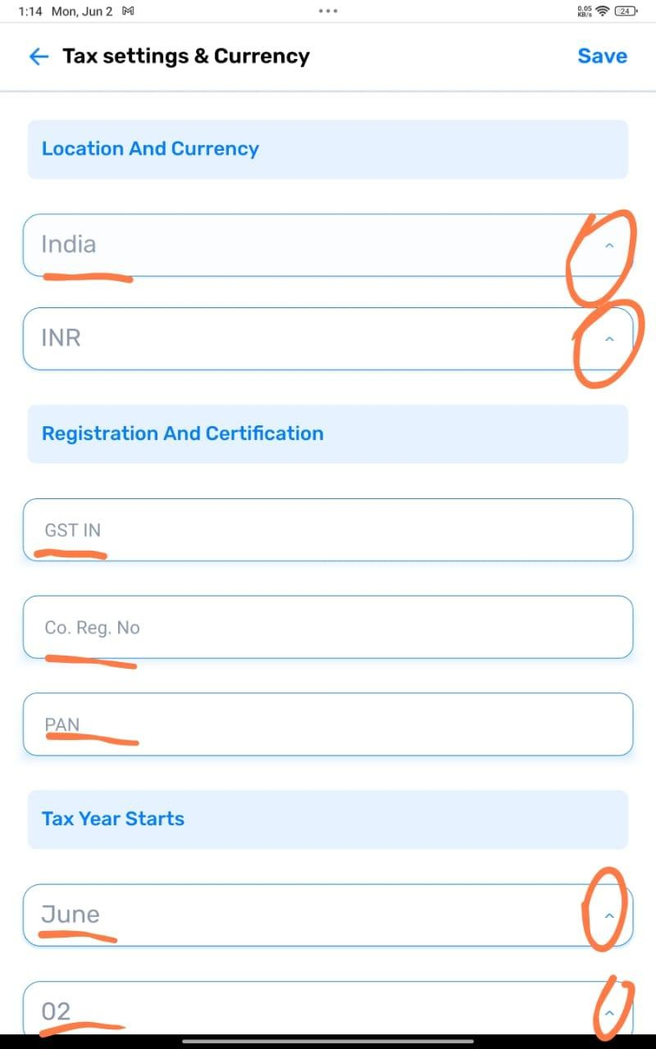 ’ 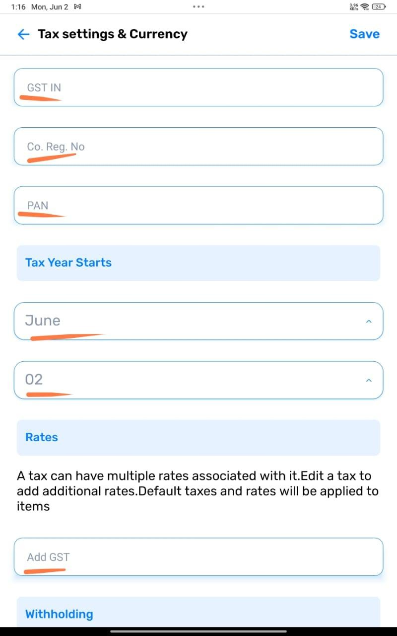

In this section, the text sizes are not consistent — some text is large, some is small. Also, the dropdown icon is facing the wrong direction.

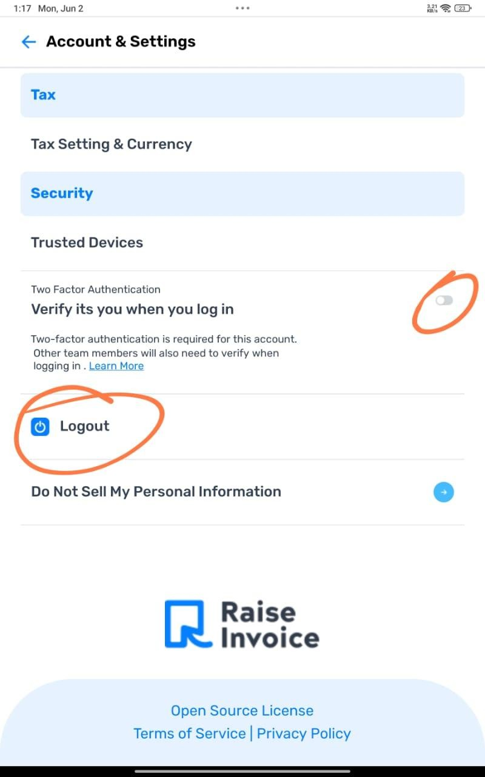

When clicking on 'Log Out', it logs out immediately. There should be a confirmation popup before logging out.

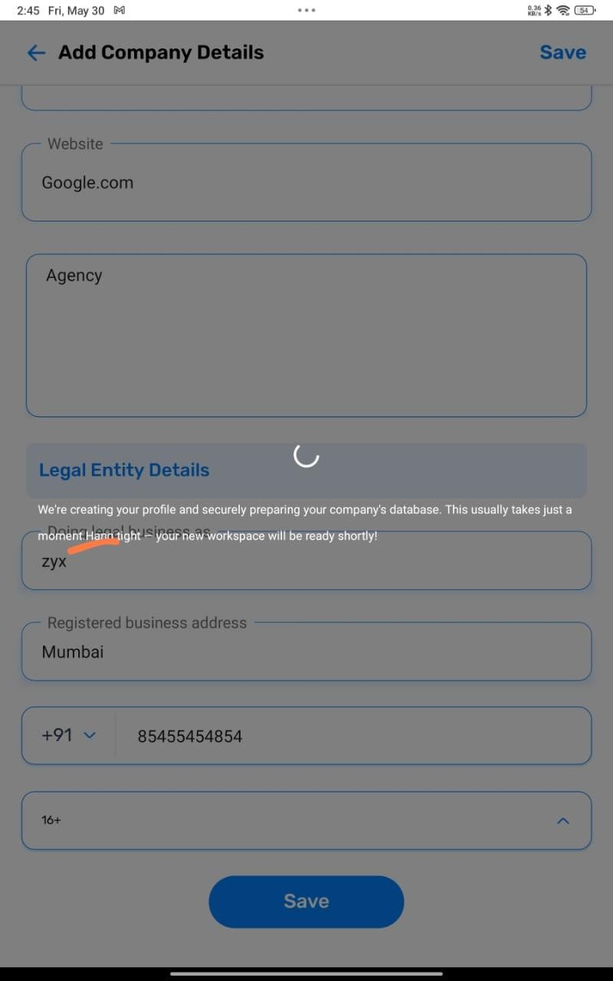

After creating a company, the message that appears after saving has no space after the full stop.

======================================================

====================================================== WEB :-

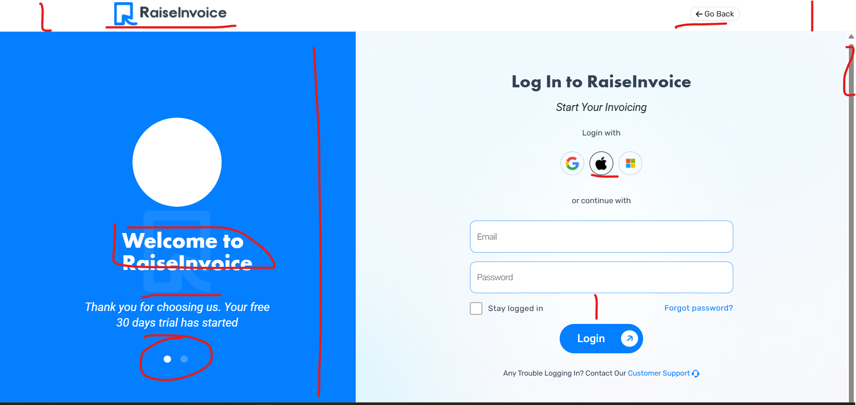

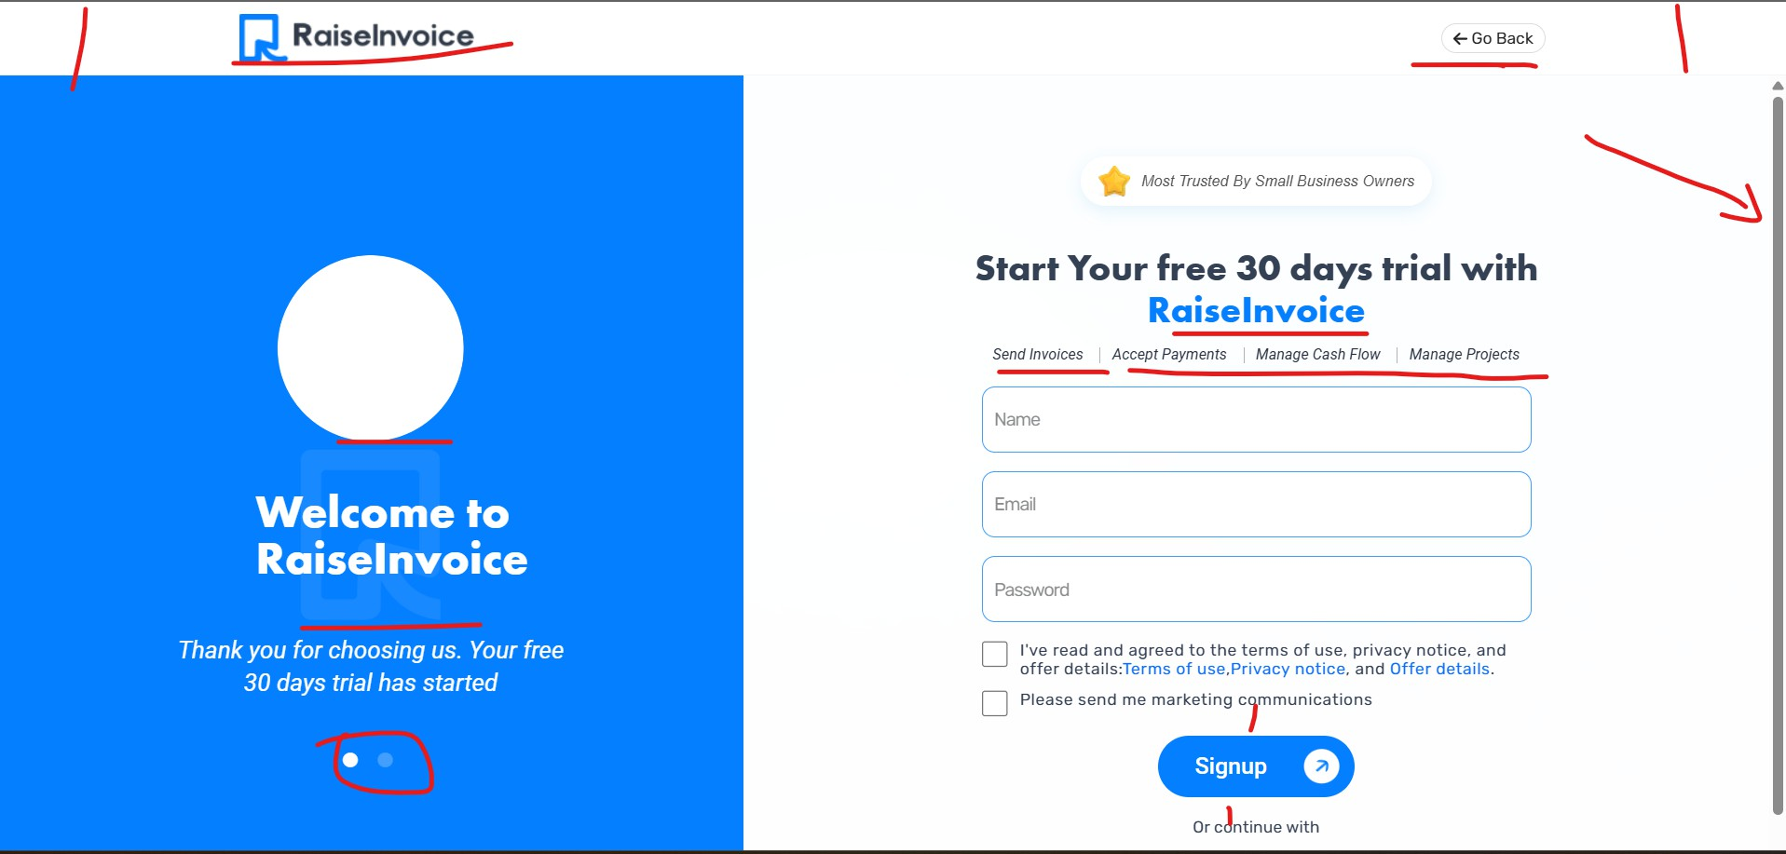

Figma
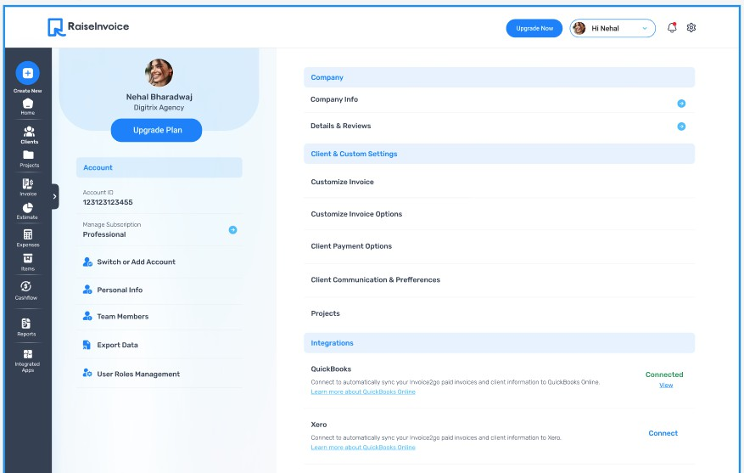
Web :- In this section, the text size, spacing, and icons are not consistent with the Figma design.

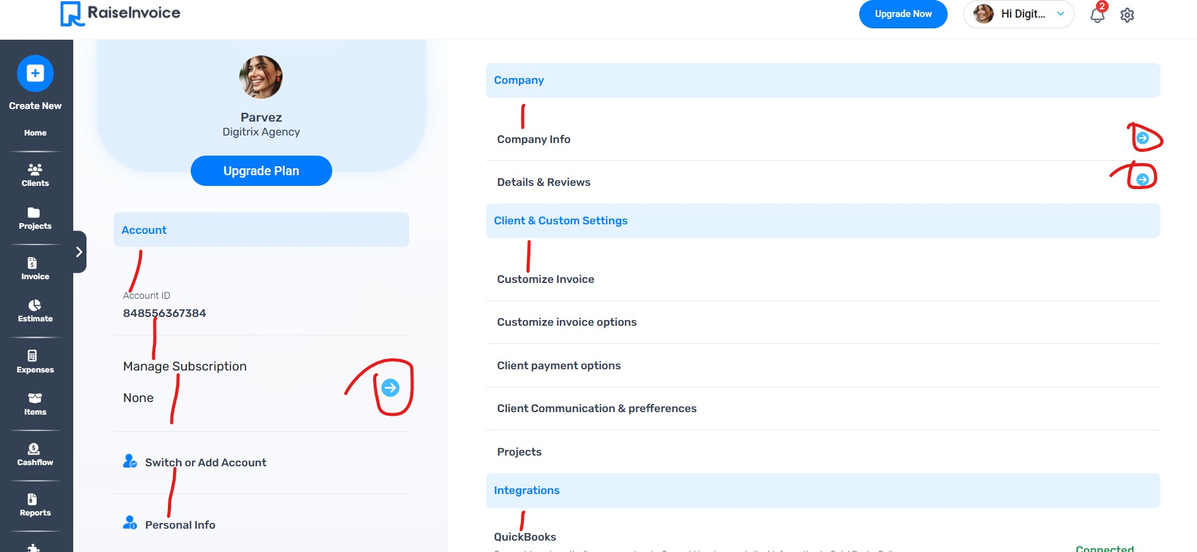

Web:- In Project Settings, the spacing, text size, and placement of the top Save button are not correct.

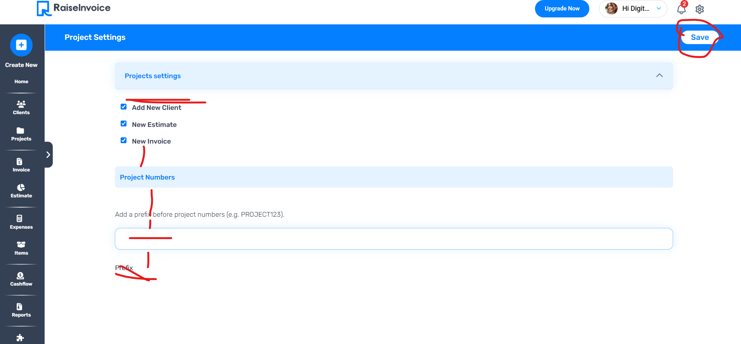

Web :- In the Language section, the dropdown and the text next to it are not properly aligned or matching.

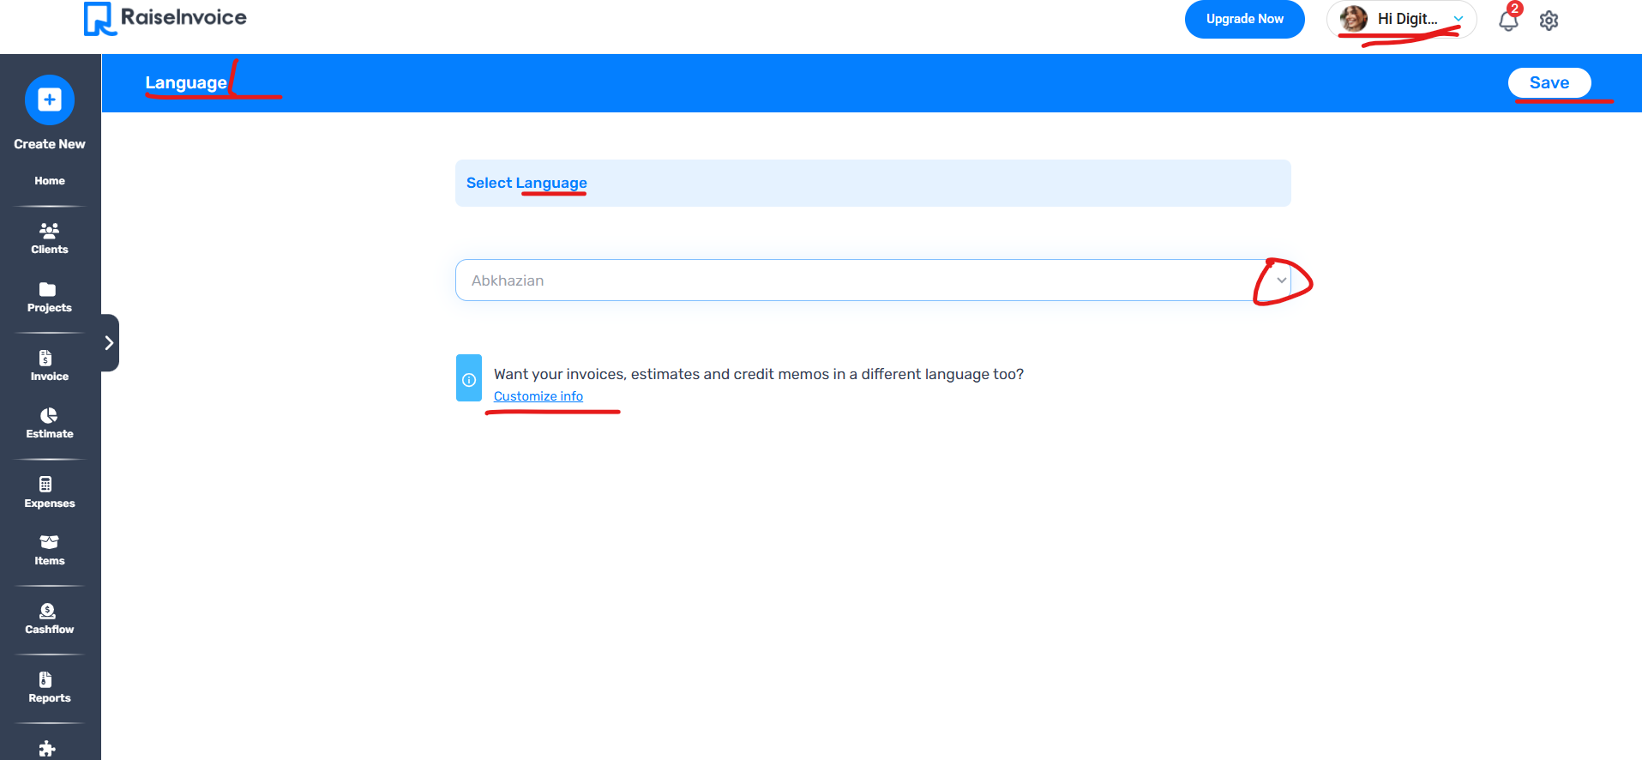

Web:- In this section, the dropdown and spacing are not matching, and in some divs, the fill is missing. Also, the toggle design doesn’t match."

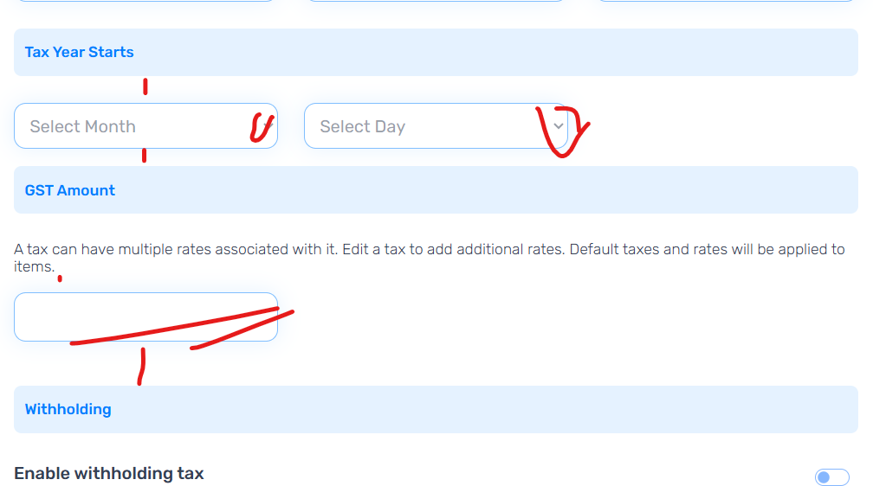

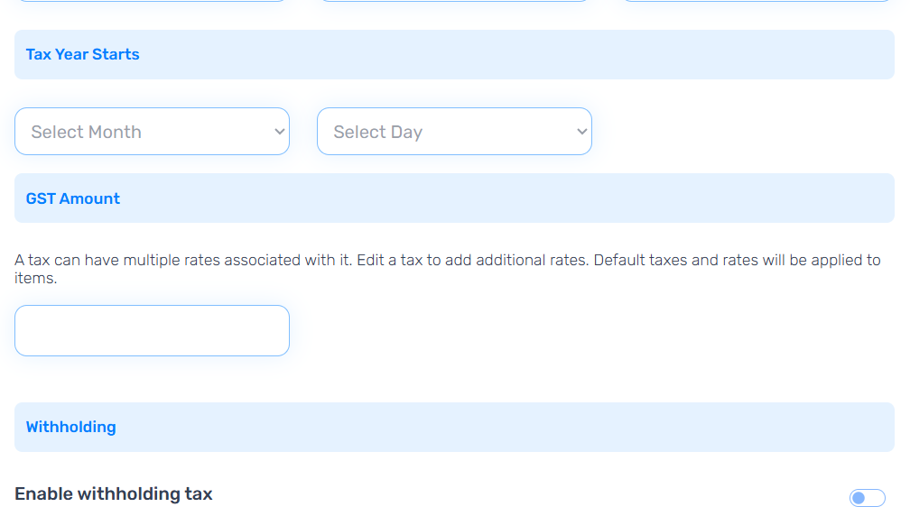

In this section, the text is not aligned properly, and the dropdown and Save button are not in the correct position.

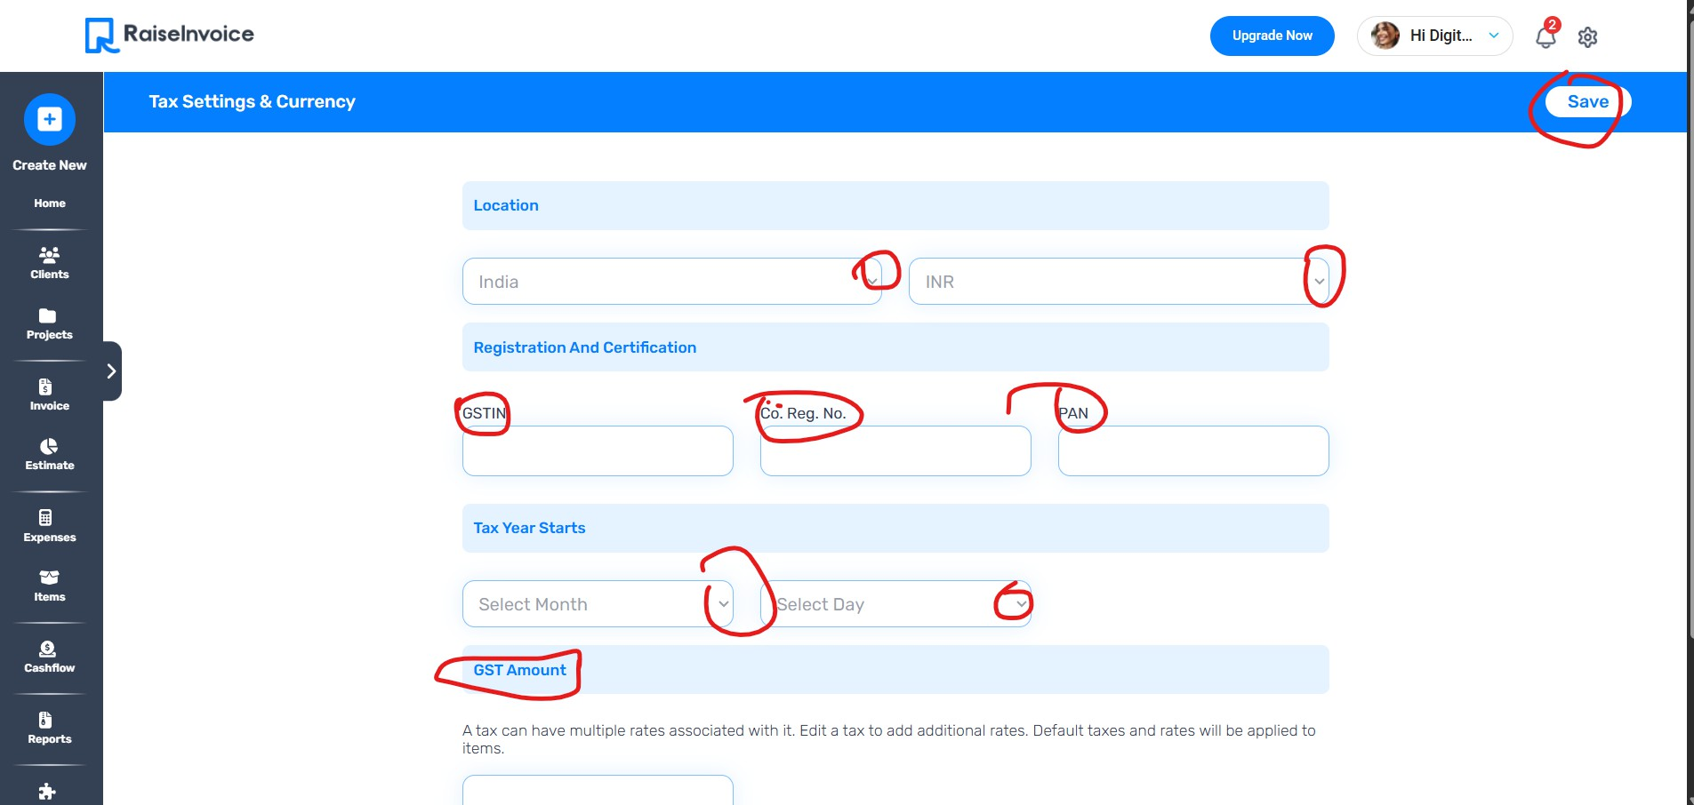

In this section, the text is not aligned properly, and the dropdown and Save button are not in the correct position.

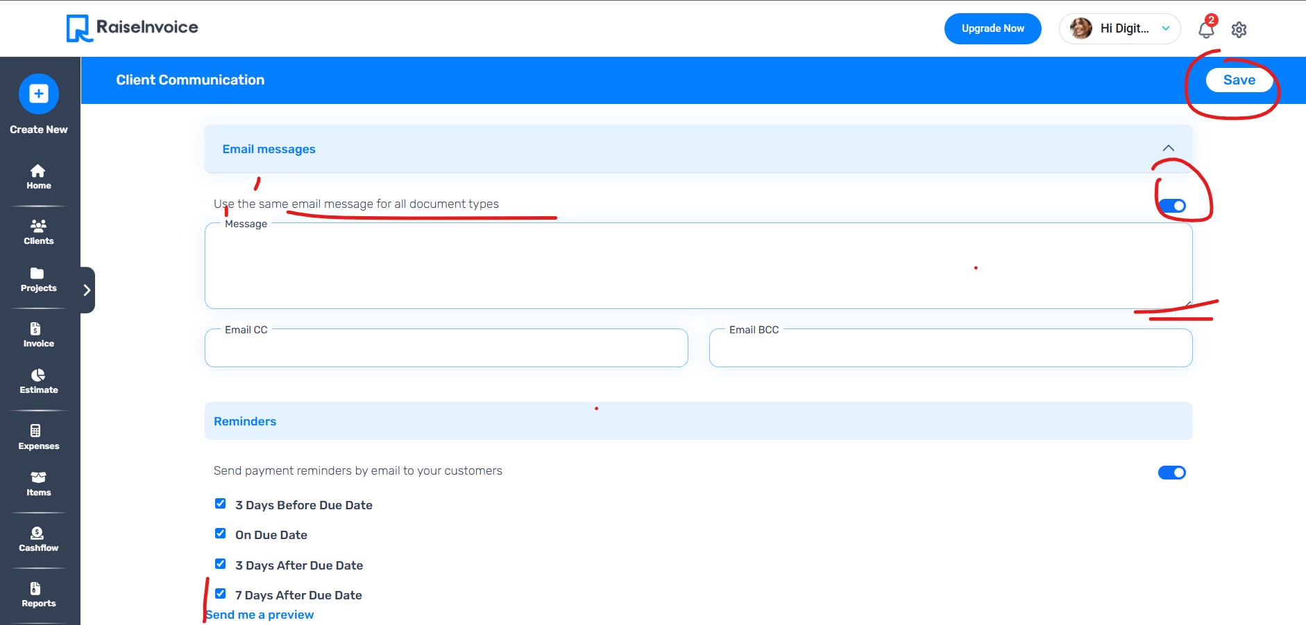

Figma
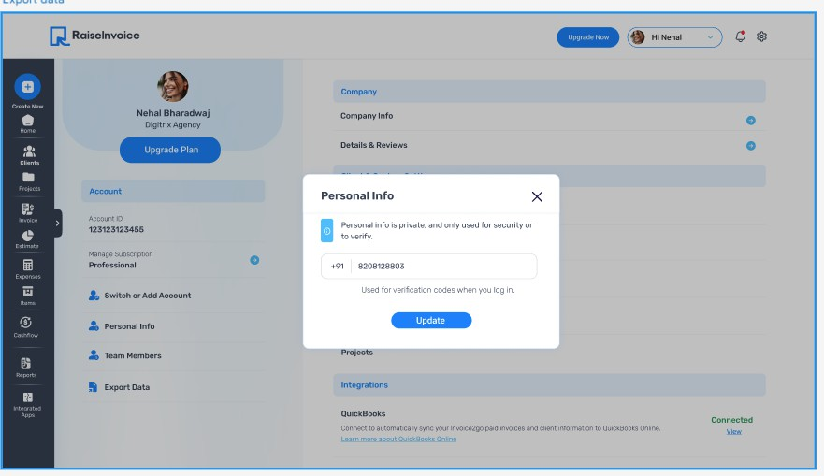

Web
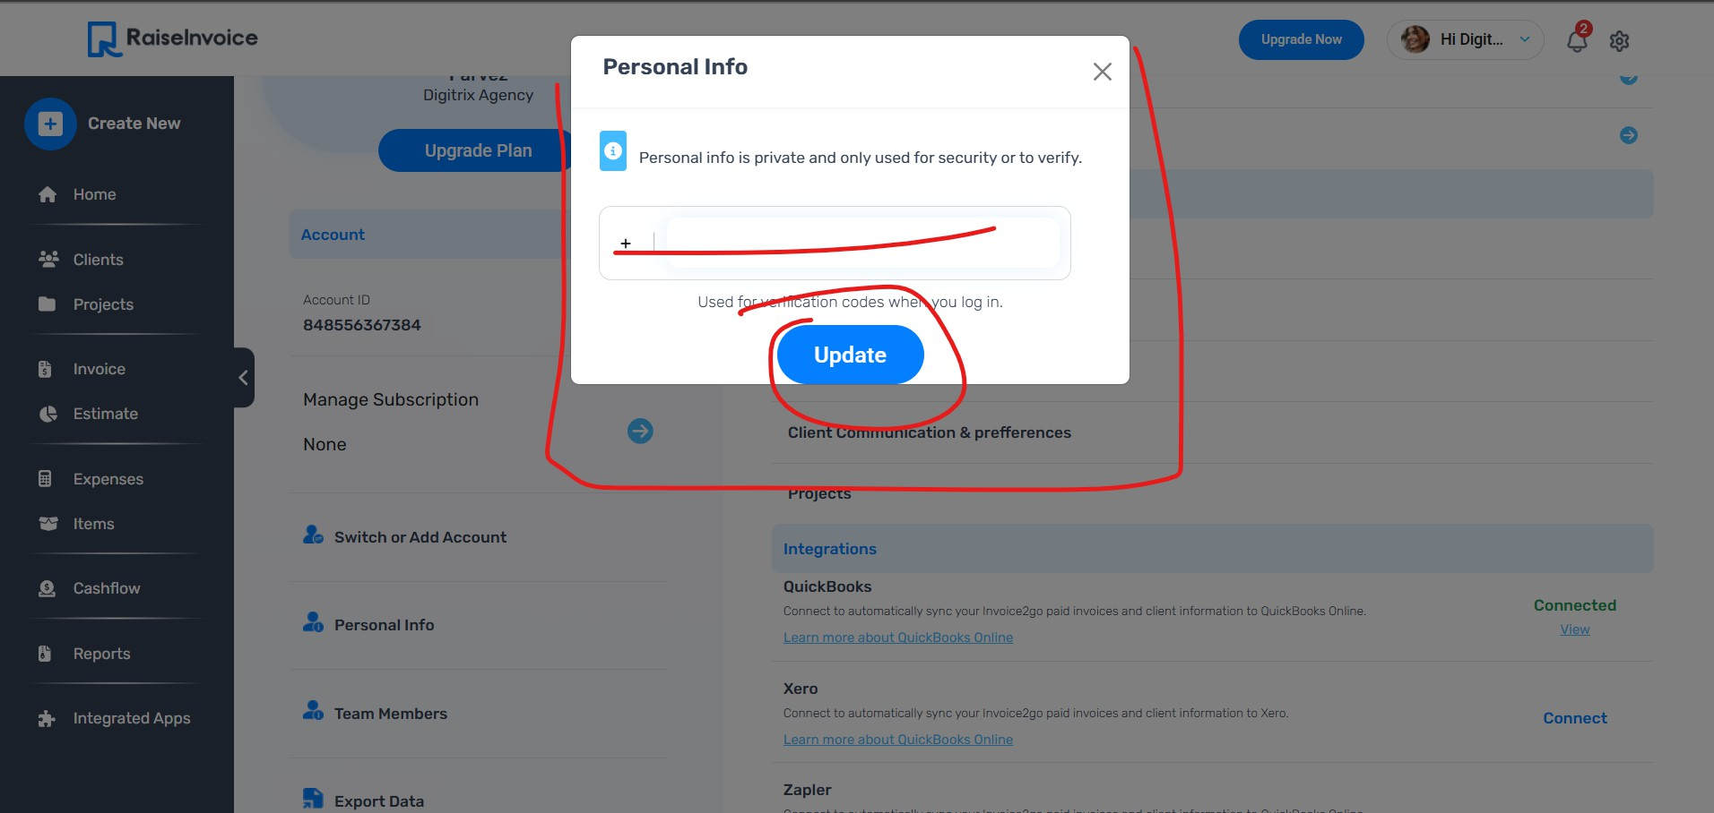

Figma
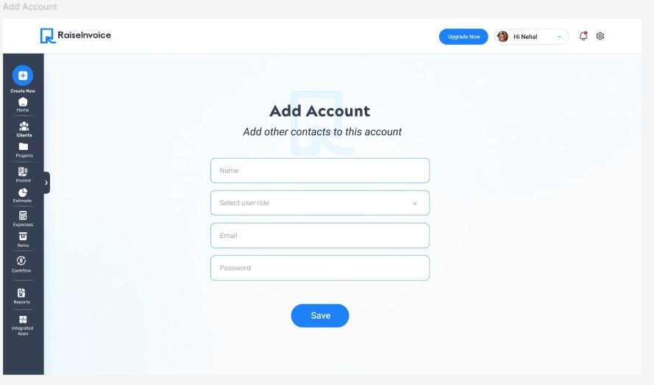
Web
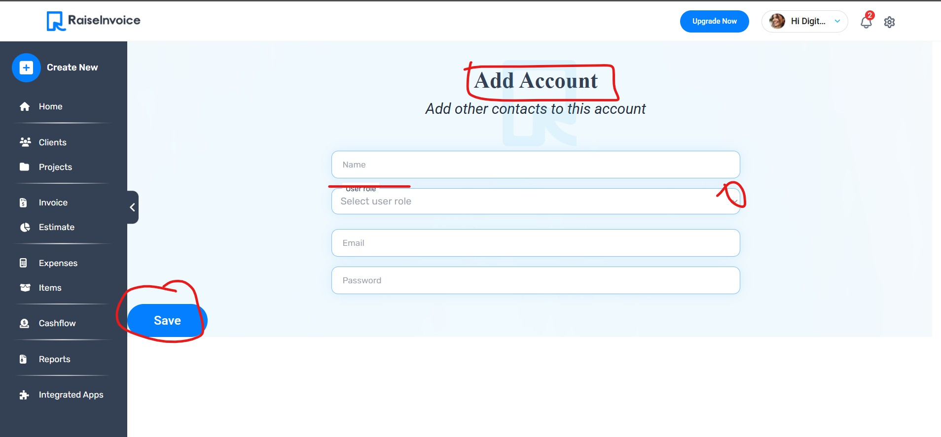

Figma
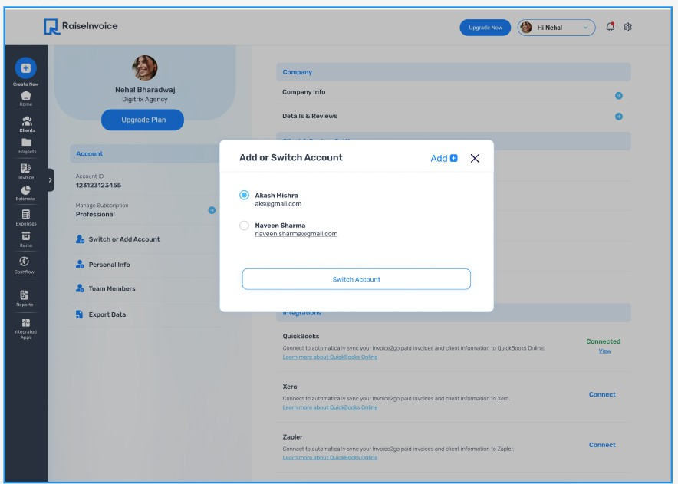

Web
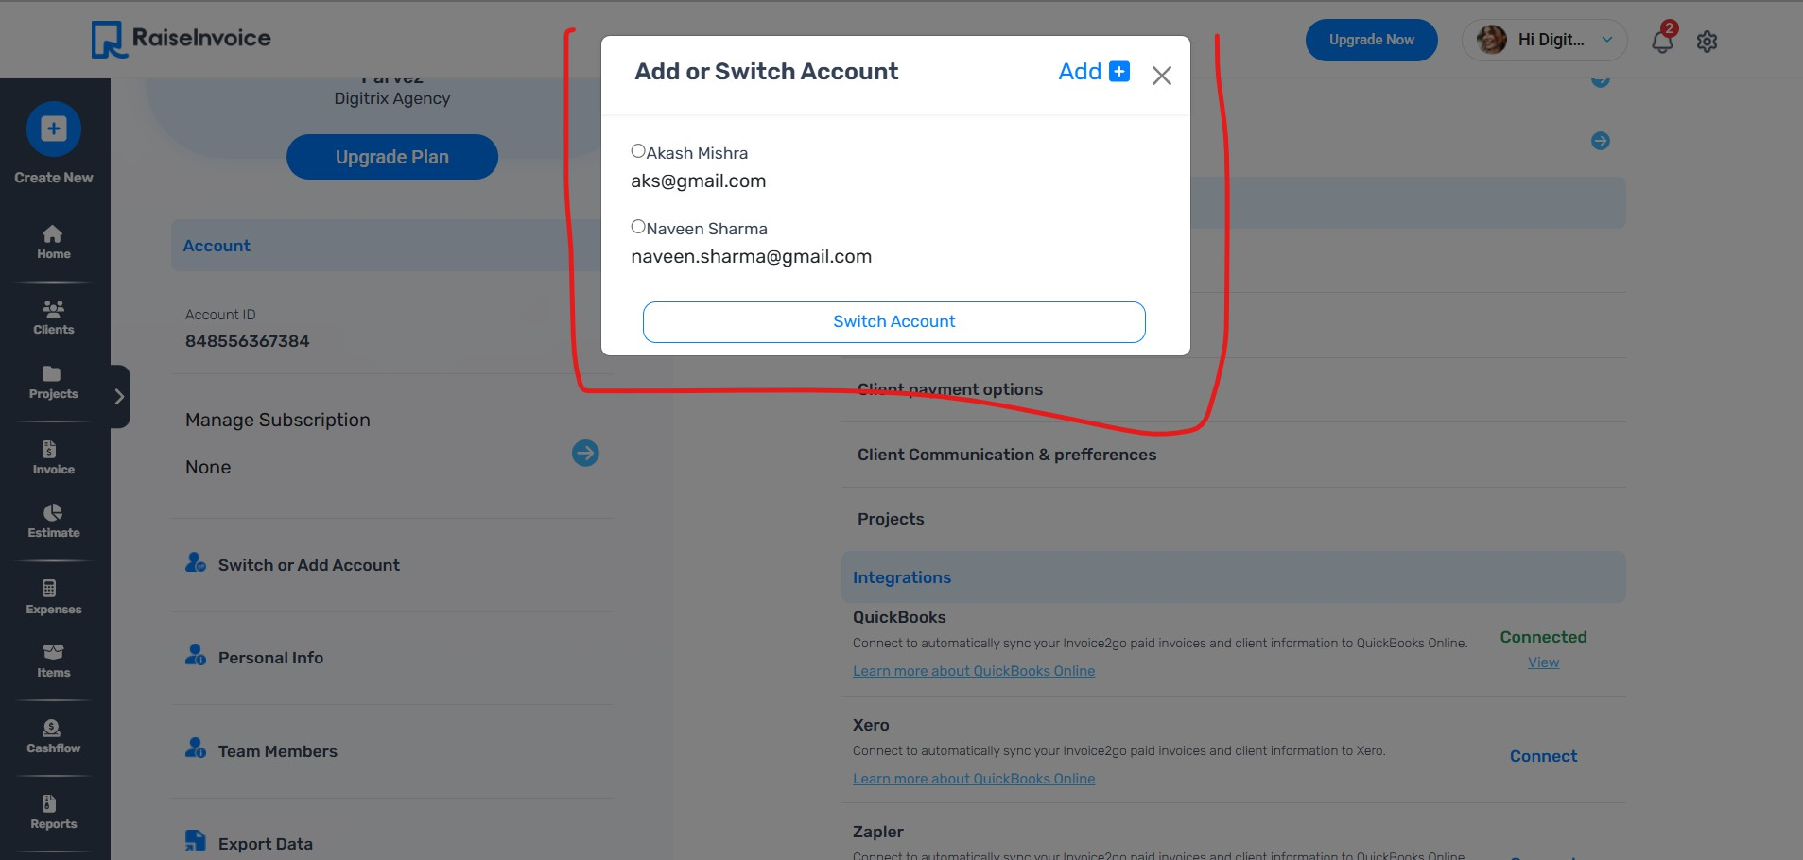

‘

Figma
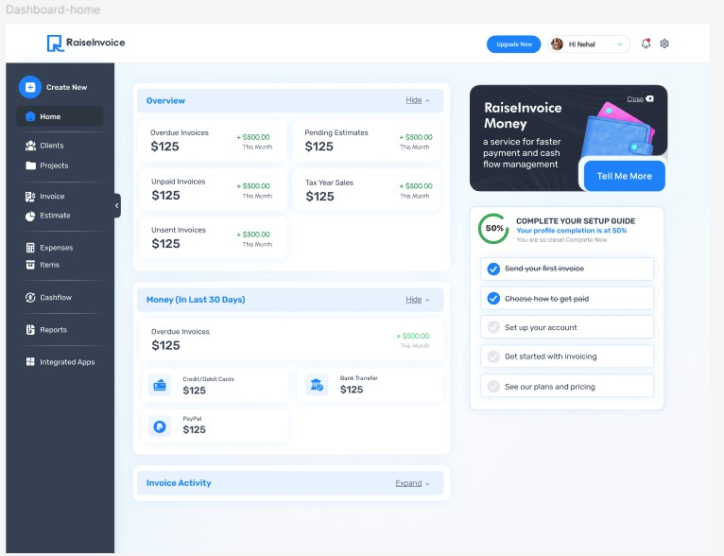
Web

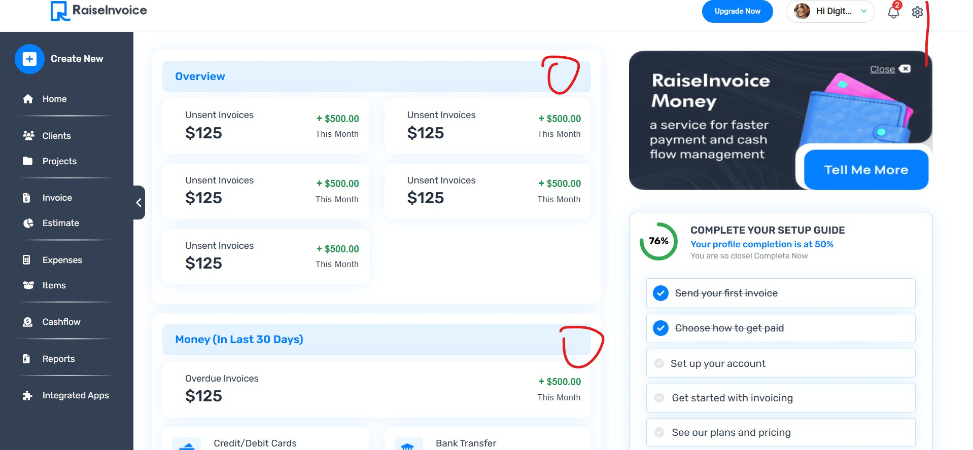
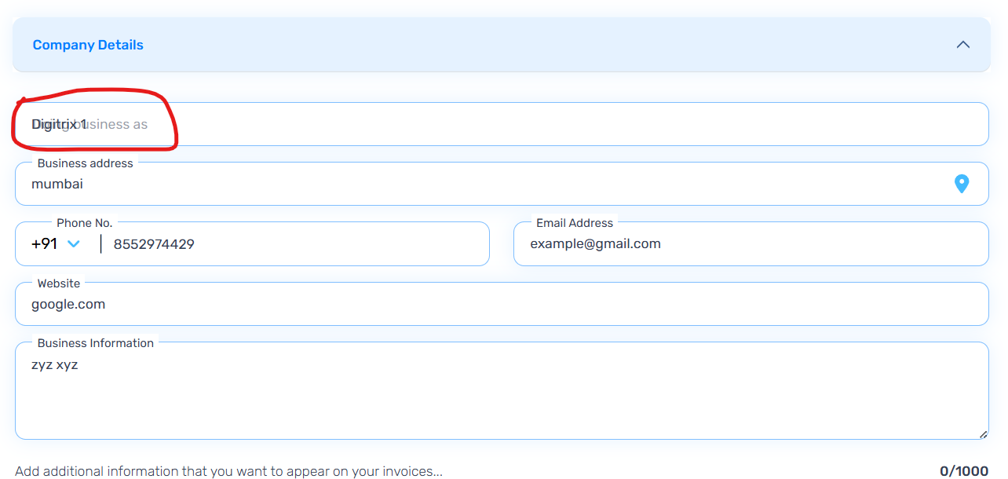

In this section, when the hover is removed, the text gets merged or overlaps

